

American International University-Bangladesh (AIUB)  
**Department of Computer Science  
Faculty of Science & Technology (FST)**

**BrainBoost: A Children Learning Management System**

A Software Requirement Engineering Project Submitted

By

|  |  |  |  |
| --- | --- | --- | --- |
| **Semester: Spring_22_23** | | **Section:** | **Group Number:** |
| SN | Student Name | Student ID | Individual Marks |
| 01. | RIYA BASAK RISHA | 20-43317-1 |  |
| 02. | MD. MAMUNUR RAHMAN MOON | 20-42439-1 |  |
| 03. | MD. TANVIR AHMED | 19-40853-2 |  |

The project will be Evaluated for the following Course Outcomes

|  |  |  |
| --- | --- | --- |
| Evaluation Criteria | Total Marks (50) | |
|  | |
| Introduction, Format, Submission, Defense | [10 Marks] |  |
| System Overall Description & Functional Requirements | [10 Marks] |  |
| System Quality Attributes and Project Requirements | [10 Marks] |  |
| UML and E-R Diagram with Data Dictionary | [10 Marks] |  |
| UI/UX Prototyping | [10 Marks] |  |

Software Requirements Specification

for

< BrainBoost: A Children Learning Management System>

Version 1.0 approved

Prepared by < RIYA BASAK RISHA, MD. MAMUNUR RAHMAN MOON, MD. TANVIR AHMED >

< American International University-Bangladesh>

<14.May.2023>

Table of Contents

Revision History 4

1. Introduction 5

1.1 Purpose 5

1.2 Document Conventions 5

1.3 Intended Audience and Reading Suggestions 6

2. Overall Description 9

2.1 Product Perspective 9

2.2 Product Functions 10

Design and Implementation Constraints 11

2.3 User Documentation 12

3. System Requirements 12

3.1 Functional Requirements (System Features) 12

3.1.1 Software Login 13

3.1.2 Registration 13

3.1.3 Communication system (Learner & Course Instructor) 14

3.1.4 LR1 - View courses and tools 14

3.1.5 LR2 - Select courses and tools 14

3.1.6 LR3 - Purchase courses and tools 15

3.1.7 LR4 - Join on live classes 15

3.1.8 LR5 - Progress Reports of the learner 15

3.1.9 LR6 - Resource Library for the learners 16

3.1.10 LR7 - Analytics activities of learner 16

3.1.11 LR8 - Feedback Mechanism of learners 16

3.1.12 AD1 - User Management of Admin 16

3.1.13 AD2 - Educational Tools Management 17

3.1.14 AD3 - Video Resource Materials Management 17

3.1.15 AD4- Admin can monitor student progress 17

3.1.16 AD5 - Admin can generate reports and analytics 17

3.1.17 AD6 - Admin can do the required customization of the system 18

3.1.18 CC1 - Upload video post (Content Creator) 18

3.1.19 CC2 - Update video post 18

3.1.20 CI1 - Post course adding request 19

3.1.21 CI2 - Course material upload 19

3.1.22 CI2 - Course material upload 19

3.1.23 CI3 - Assign quiz or assignment 20

3.1.24 CI2 - Review the quiz or assignment 20

3.1.25 ETM1 – Upload tool description for eligibility 20

3.1.26 ETM2 – Update tools description and price 21

3.2 Non-Functional/Quality Requirements 21

3.3 Project Requirements 22

4. Design and Interface Requirements 23

4.1 UML Diagrams 23

4.2 Data Dictionary 24

4.3 UI/UX Design Specification 25

4.3.1 Wireframes 25

4.3.2 Paper prototypes 27

4.3.3 Mockups 28

5. COST Analysis: 33

# Revision History

|  |  |  |  |
| --- | --- | --- | --- |
| **Name** | **Date** | **Reason for Changes** | **Version** |
| System Description | 24.04.2023 | Extending the system capacity | 1.1 |
| Use Case Diagram | 01.05.2023 | Added a new user (Tool Manufacturer) | 1.1 |
| User deprecated | 04.05.2023 | Deprecated a user (Sponsor) | 1.2 |
| Feature elicitation | 07.05.2023 | Complexity of system design | 1.3 |
| Modified paper prototype | 09.05.2023 | Change of usability | 1.4 |
| Changed UI/UX Design | 10.05.2023 | Prioritized features | 1.4 |

# Introduction

## Purpose

The purpose of the SRS (Software Requirement & Specification) document for the Children Learning Management System (CLMS) is to clearly define the functional and non-functional requirements of the system. The SRS serves as a comprehensive reference document that captures the needs, expectations, and constraints of the stakeholders involved in the development and deployment of the LMS.

The product’s goal is to create a digital learning management system for children. This system will provide an easy-to-use platform for **parents**, **course instructors**, and **learners (children)** to access educational materials, track progress. The learners and course instructors can communicate with each other through the built-in messaging system. It will also provide a variety of educational tools and resources to help children learn and grow. The system will be designed to be intuitive and user-friendly so that it can be used by all ages. Admin can manage this system easily with the software. Last but not least, this system is digitized to free up a lot of time so that individuals can use it.

## Document Conventions

* **Bold words:** Important words are in bold for highlighting.
* **Hierarchical Numbering Structure:** Hierarchical Numbering Structurehave been used for categorizing each category of the SRS documents.
* **Sequence and hierarchical numbering:** Functions/Featureshave been written in a manner where textual keywords used for the purpose of being the feature scope self-explanatory.

**For example:**

CI - Review the quiz or assignment

**Here,** CI means Course Instructor; thus, it is a feature related to the Course Instructor.

* **Used keywords: CLMS** (Children Learning Management System)**, CI** (Course Instructor), **AD** (Admin), **CC** (Content Creator), **LR** (Learner), **ETM** (Educational Tool Manufacturer)

## Intended Audience and Reading Suggestions

When considering the intended audience for a document related to a Learning Management System (CLMS), there are several types of readers to consider, each with their specific roles and responsibilities. Here are the different types of readers that the document may be intended for:

* **Developers:** These readers are primarily interested in technical details, code documentation, and system architecture. They need information about the CLMS's underlying technology, programming languages, APIs, and integration options. They may also require guidance on customizing or extending the CLMS through development.
* **Project Managers:** Project managers are responsible for overseeing the implementation of the CLMS within an organization. They require information about project timelines, resource allocation, budgeting, and high-level project planning. They may also need documentation on deployment strategies, risk management, and project management methodologies.
* **Marketing Staff:** Marketing staff focuses on promoting the CLMS to potential customers or users. They require documentation that highlights the CLMS's key features, benefits, and competitive advantages. This includes marketing collateral, user case studies, product brochures, and any other materials that can help market the CLMS effectively.
* **Users:** These readers encompass a wide range of individuals who will interact with the CLMS on a regular basis. They include teachers, instructors, trainers, students, or employees, depending on the context. User documentation should provide clear instructions on how to use the CLMS, including login procedures, course enrollment, content creation and management, assessment tools, and communication features.
* **Testers:** Testers play a critical role in ensuring the quality and functionality of the CLMS. They require detailed documentation on test plans, test cases, and instructions on how to execute various types of tests, including functional testing, usability testing, performance testing, and security testing. This documentation helps them identify and report any issues or bugs they encounter during the testing process.
* **Documentation Writers:** These readers are responsible for creating and maintaining the official documentation for the CLMS. They require comprehensive information about the CLMS's features, configuration options, system requirements, troubleshooting guides, frequently asked questions (FAQs), and other relevant details. They use this information to produce user manuals, administrator guides, API references, and other forms of documentation.

It is important to tailor the document content and style to the specific needs and expertise of each type of reader to ensure that the information provided is relevant, clear, and effective for its intended audience.

When organizing the document for an CLMS, it's essential to provide a logical sequence that allows readers to grasp the key information they need. **Here's a suggested sequence for reading the document, starting with the overview sections and then proceeding through sections that are most pertinent to each reader type:**

* **Introduction and Executive Summary:** Begin with an introduction that provides an overview of the document's purpose, scope, and objectives. Follow it with an executive summary that highlights the key features and benefits of the CLMS.
* **General Overview:** Provide a general overview of the CLMS, including its main functionalities, target audience, and the benefits it offers. This section can be useful for all reader types to get a high-level understanding of the CLMS.
* **Developers:**

1. **Technical Architecture:** Explain the technical architecture of the CLMS, including its components, database structure, and integrations with other systems.
2. **APIs and Integration:** Describe the available APIs and integration options, including documentation on how to interact with the CLMS programmatically.
3. **Customization and Extension:** Provide guidance on how developers can customize and extend the CLMS to meet specific requirements.

* **Project Managers:**

1. **Project Timeline and Planning:** Present a detailed project timeline, outlining the different stages, milestones, and dependencies involved in implementing the CLMS.
2. **Resource Allocation:** Provide information on the resources required for successful CLMS implementation, including human resources, budget, and infrastructure needs.
3. **Deployment Strategies:** Explain various deployment options and their implications, such as cloud-based hosting or on-premises installation.
4. **Risk Management:** Discuss potential risks associated with CLMS implementation and strategies to mitigate them.

* **Marketing Staff:**

1. **Key Features and Benefits:** Highlight the CLMS's key features and the benefits it offers to potential users, emphasizing its unique selling points.
2. **Target Market Analysis:** Provide insights into the target market for the CLMS, including industry trends, user demographics, and competitor analysis.
3. **Marketing Collateral:** Include sample marketing collateral, such as brochures, presentations, or videos, to help marketing staff effectively promote the CLMS.

* **Users:**

1. **User Guide:** Provide a comprehensive user guide that explains how to navigate the CLMS, enroll in courses, access learning materials, participate in discussions, and track progress.
2. **Content Creation and Management:** Describe the process of creating and managing course content, including multimedia integration, assessments, and grading.
3. **Communication Features:** Explain the various communication tools available within the CLMS, such as chat, discussion forums, and messaging systems.

* **Testers:**

1. **Testing Procedures:** Provide detailed instructions on how to perform different types of tests, including functional testing, usability testing, performance testing, and security testing.
2. **Test Cases:** Include a collection of test cases that cover the most critical functionalities and potential edge cases of the CLMS.

* **Documentation Writers:**

1. **Administrator Guide:** Offer a comprehensive guide for administrators, explaining how to configure and manage the CLMS, including user roles, permissions, and system settings.

1. **Troubleshooting and FAQs:** Provide troubleshooting guides and a list of frequently asked questions to address common issues and challenges users may encounter.

By organizing the document in this suggested sequence, readers can quickly locate the information relevant to their roles and responsibilities, ensuring a smooth and efficient reading experience.

If there is any problem of understanding or there is any unwanted mistake then readers are encouraged to contact the contributors of the report. This is a list of those who contributed to this report. This mailing group will be sent the draft for feedback and input.

|  |  |
| --- | --- |
| **Name** | **E-mail** |
| Riya Basak Risha | riyabasak121@gmail.com |
| Md Mamunur Rahman Moon | mamunurrahmanmoon@gmail.com |
| Md Tanvir Ahmed | tanvirahmed0199444@gmail.com |

# Overall Description

## Product Perspective

The **“BrainBoost: A Children Learning Management System”** is a **new product** developed for the better learning environment and to ensure effective learning.

The LMS serves as a hub for educational content, enabling course instructors to create and manage multimedia resources, including videos, quizzes, and interactive lessons. This content can be organized by subject, grade level, or other criteria, making it easy for teachers to customize their teaching materials. The LMS also allows for the integration of external educational tools, expanding the available learning options for students.

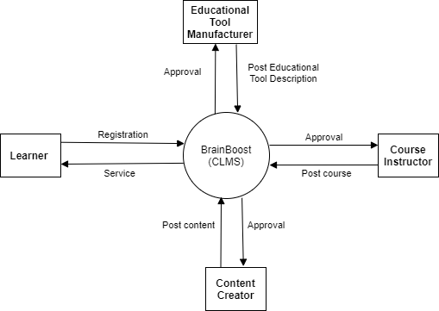

***Figure-1:*** *Main components of the CLMS (Control flow diagram)*

## Product Functions

* Registration page (For all users)
* Login page (For all users)
* Log-out (For all users)
* View courses (Learner)
* Enroll course (Learner)
* View tools & videos (Learner)
* Purchase tool (Learner)
* Update course (Course Instructor)
* Post videos (Content creator)
* Post tool description (Educational Tool Manufacturer)
* Approve post & videos (Admin)
* Manage users account (Admin)
* Customize system (Admin)

The Learning Management System (LMS) will operate in a specific environment that includes the hardware platform, operating system, and other software components. Here is a description of the environment:

**Hardware Platform:** The hardware platform should be able to support the software and its users. This includes having enough RAM, storage, and processing power to handle the number of users expected.

**Operating System and Versions:** The LMS should be compatible with popular operating systems such as Windows, MacOS, and Linux in educational settings. The system should support Windows 10, Windows 8, Windows 7, macOS Catalina, macOS Mojave, macOS Big Sur, Ubuntu, Fedora, CentOS, etc.

**Mobile Operating Systems:** The LMS should also have support for mobile operating systems to provide access to educational content on smartphones and tablets. The LMS should be compatible with commonly used mobile operating systems to ensure access across different platforms such as iOS, Android, Blackberry, and so on. The system should be compatible with the latest versions of all mobile operating systems.

**Web Browsers:** The LMS should be compatible with commonly used web browsers to ensure access across different platforms such as Google Chrome, Mozilla Firefox, Microsoft Edge, and so on. The system should be fully compatible with the latest versions of all web browsers.

## Design and Implementation Constraints

**Security and Privacy:** Given the sensitive nature of educational data, the CLMS must prioritize security and privacy. It should implement robust authentication mechanisms, data encryption, secure connections, and access controls to protect user information and prevent unauthorized access.

**Database technology:** The CLMS should be developed using the PHP MyAdmin database and query will be written as per the technology of the database system.

**Programming language:** The CLMS should be developed using the latest version of PHP and JavaScript.

**Compatibility:** The CLMS needs to be compatible with various operating systems, browsers, and devices to ensure broad accessibility for users. It should be designed and tested to work seamlessly across different platforms.

**Scalability:** The CLMS should be designed to handle a large number of concurrent users and be capable of scaling up as the user base grows. The system architecture should support scalability without compromising performance or user experience.

**Performance:** The CLMS should be designed to deliver a responsive and smooth user experience. It should be optimized for quick loading times, efficient data retrieval, and minimal downtime. Performance testing and optimization techniques should be employed during development.

**Usability and User Experience:** The CLMS should prioritize a user-friendly interface and intuitive navigation. It should be designed to accommodate users of varying technical skills and provide clear instructions and guidance throughout the platform.

**Localization:** The CLMS need to support Bangla and English language and other language for international deployment.

## User Documentation

Following User Documentation Components will be provided:

1. **User Manual:** A comprehensive guide to the system, including instructions on how to use the system, troubleshooting tips, and other relevant information.
2. **On-line Help:** Context-sensitive help topics that provide users with detailed information about specific features of the system.
3. **Tutorials:** Step-by-step instructions on how to use the system, including screenshots and videos.
4. **FAQs:** A list of frequently asked questions and answers about the system.

Following user documentation delivery formats or standards will be provided:

1. **HTML:** Hypertext Markup Language is a standard for creating web pages and delivering user documentation online.
2. **PDF:** Portable Document Format is a standard for delivering user documentation in a printable format.
3. **CHM:** Compiled HTML Help is a standard for delivering user documentation in a single, compressed file.

# System Requirements

## Functional Requirements (System Features)

A Learning Management System (CLMS) typically comprises a variety of functional requirements or system features that enable the efficient management of online courses and the tracking of student progress. Some of these features may include the ability to create and manage course content, such as lectures, quizzes, and assignments, as well as tools for learners’ assessment and grading. Other key features may include student enrollment and registration, user management, communication and collaboration tools, as well as reporting and analytics to track learner performance and identify areas for improvement. Additionally, an CLMS may integrate with third-party systems, such as video conferencing or e-commerce platforms, to provide a more comprehensive learning experience. Ultimately, the functional requirements of an CLMS are designed to support both the instructor and the learner in achieving their educational goals in a streamlined and effective manner.

### Software Login

* + The software shall allow users to login with their given username and password.
  + The login credentials (username and password) will be verified with database records.
  + If the login successful, the home page of the user account will be displayed.
  + If the username and/or password has been inserted wrong, the random verification code will be generated and sent to the user’s email address by the system to retry login.
  + If the number of login attempt exceed its limit (3 times), the system shall block the user account login for one hour.

**Priority Level:** High

**Precondition:** Usershave valid user id and password.

**Cross-references:** 3.1.2

### Registration

* Allows users to create an account to access the system.
* Ensures that the user's email address or phone number is valid before allowing access to the system.
* Allows users to login using their social media accounts like Facebook, Google, or Twitter.
* Allows users to create custom roles with different permissions and access levels for users.
* Users will be able to re-type their password for ensuring the password.

**Priority Level:** High

**Precondition:** User should have a valid phone no.

**Cross-references:** N/A

### Communication system (Learner & Course Instructor)

* + The messaging system should be integrated within the CLMS and allow parents to communicate with their child's instructor directly through the platform.
  + This feature should also allow parents to see messages from the teacher or educator and respond accordingly.
  + The messaging system should allow parents and teacher to share files if needed.

**Priority Level:** High **Precondition:** N/A.  
**Cross-references:** 3.1.4

### LR1 - View courses and tools

* + The software shall allow learners to view the courses and tools.
  + The course or tools will be seen in a list.
  + Detailed information of the course and tools, including learning objectives, course outline, and grading criteria will be seen.
* A searchable directory of courses offered

**Priority Level:** High **Precondition:** The learner will see the list if and only if he/she has a registered account and logged in that account.  
**Cross-references:** N/A

### LR2 - Select courses and tools

* + The software shall allow learners to select the courses and tools.
  + The CLMS will display the course schedule, including the start and end dates, course duration, and any important dates or deadlines.
  + If courses are not free, the CLMS should offer a payment processing system to handle transactions securely.
* The CLMS should provide a certificate or digital badge upon completion of a course, which learners can share on their resume or social media profiles.

**Priority Level:** High **Precondition:** N/A  
**Cross-references:** N/A

### LR3 - Purchase courses and tools

* + The software shall allow learners to purchase courses and tools.
  + The ability for learners to view their order history, including the courses and tools they have purchased.
  + The software shall allow learners to view the date of purchase.
* The amount paid will also be viewed.

**Priority Level:** High **Precondition:** N/A.  
**Cross-references:**

### LR4 - Join on live classes

* + Learners will be able to join class which will be conducted by the instructors.
  + Learners will be able to leave class which is joined.
  + Will have access to a calendar with scheduled live classes.
  + Audio and video communication tools to interact with the instructor and other learners.
  + Will have access to chat and messaging features.

**Priority Level:** High **Precondition:** N/A  
**Cross-references:** N/A

### LR5 - Progress Reports of the learner

* The software shall be generated the progress reports automatically based on the child's activity within the platform.
* The reports should be easy to understand and provide actionable insights into the child's strengths and areas for improvement.
* The CLMS system software should allow parent & instructors to download the progress reports as a PDF file.

**Priority Level:** High  **Precondition:** Learners have to attend in any examination.  
**Cross-references:** N/A

### LR6 - Resource Library for the learners

* The resource library should provide learners with access to a range of educational materials, including videos and educational tools that can help support their learning outside of the CLMS platform.
* The CLMS system should allow learners to view items and add to wish-list.
* The CLMS system should allow learners to buy tools from the resource library.

**Priority Level:** High **Precondition:** Users have valid user id and password.  
**Cross-references:** N/A

### LR7 - Analytics activities of learner

* The analytics feature should provide learners with insights into their learning behavior.
* The analytics feature should provide learners how much time they spend on each activity, which activities they find most engaging, and areas where they may be struggling.

**Priority Level:** Medium **Precondition:** Users have valid user id and password.  
**Cross-references:** N/A

### LR8 - Feedback Mechanism of learners

* The feedback mechanism should provide learners with a way to offer feedback to the CLMS development team about their experience using the platform.
* This feature should also allow learners to report any issues they encounter or suggest improvements to the platform.

**Priority Level:** Medium **Precondition:** Users have to be logged in.  
**Cross-references:** 3.1.2

### AD1 - User Management of Admin

* The CLMS should allow school administrators to manage user accounts for learners, instructors, content creators and educational tool manufacturers.
* This feature should include the ability to create, modify, and delete user accounts as needed.

**Priority Level:** High **Precondition:** N/A  
**Cross-references:** N/A

### AD2 - Educational Tools Management

* The CLMS should allow school administrators to check eligibility for the tools those are posted by manufacturers.
* This feature should include the ability to allow or postpone or delete tool manufacturers post or request if any irrelevance is found.

**Priority Level:** High **Precondition:**  N/A  
**Cross-references:** N/A

### AD3 - Video Resource Materials Management

* The CLMS should allow school administrators to check eligibility for the videos those are posted by content creators.
* This feature should include the ability to allow or postpone or delete any content for content creators post or request if any irrelevance is found.

**Priority Level:** High **Precondition:** N/A  
**Cross-references:** N/A

### AD4- Admin can monitor student progress

* The CLMS should allow admins to involve monitoring student progress
* This feature should allow admins to track leaner’s attendance
* This feature should allow admins to track leaner’s engagement
* This feature should allow admins to monitor leaner’s overall performance

**Priority Level:** High **Precondition:** N/A  
**Cross-references:** N/A

### AD5 - Admin can generate reports and analytics

* The CLMS should allow admins to generate reports and analytics that provide insights into learner’s attendance, result and class performance.
* The CLMS should allow admins to put comments on the overall report of the student.

**Priority Level:** High **Precondition:**  A learner should be enrolled in a course.  
**Cross-references:** N/A

### AD6 - Admin can do the required customization of the system

* The CLMS should allow admin to customize the platform to fit their specific needs and requirements.
* This feature should include the ability to add custom branding
* This feature should allow admin to configure settings
* This feature should allow admin to add different classrooms or departments.

**Priority Level:** High **Precondition:** N/A  
**Cross-references:** N/A

### CC1 - Upload video post (Content Creator)

* The software shall give the ability for content creators to upload videos to the CLMS
* The ability to support a range of video file formats, including MP4, MOV, or AVI.
* The ability to add closed captions to the video to make it accessible to learners with hearing impairments.
* The CLMS should provide privacy options for videos, such as making them public, private, or accessible to specific groups or individuals only.

**Priority Level:** High **Precondition:** N/A  
**Cross-references:** N/A

### CC2 - Update video post

* The software shall give the ability for content creators to update the title of videos.
* The ability to update closed captions.

**Priority Level:** Medium **Precondition:** N/A  
**Cross-references:** N/A

### CI1 - Post course adding request

* + The software shall allow course instructor to post a course adding request to the system.
  + The software shall allow course instructor to upload course introductory video longer than 3 minutes.
  + The software shall allow course instructor to upload a range of video file formats, including MP4, MOV, or AVI.
  + The software must require course outline and description before posting the request.
  + The software shall allow course instructor to set the enrollment fee.

**Priority Level:** Medium **Precondition:** N/A  
**Cross-references:** N/A

### CI2 - Course material upload

* + The software shall allow course instructor to upload the course materials after course have been approved.
  + The software shall allow course instructor to customize the allocation of study materials, quizzes and assignments.

**Priority Level:** Medium **Precondition:** N/A  
**Cross-references:** N/A

### CI2 - Course material upload

* + The software shall allow course instructor to upload the course materials after course have been approved.
  + The software shall allow course instructor to customize the allocation of study materials, quizzes and assignments.

**Priority Level:** Medium **Precondition:** N/A  
**Cross-references:** N/A

### CI3 - Assign quiz or assignment

* + The software shall allow course instructor to assign new assignment or quiz.
  + The software shall allow course instructor to set start time and end time to the assignment or quiz.
  + The software shall allow course instructor to delete any previously assigned assignment or quiz.
  + The software shall allow course instructor to set mark of the assignment or quiz.

**Priority Level:** Medium **Precondition:** N/A  
**Cross-references:** N/A

### CI2 - Review the quiz or assignment

* + The software shall allow course instructor to show the answers/answer scripts of the assigned assignment or quiz.
  + The software shall allow course instructor to show the result of the assigned assignment or quiz.
  + The software shall allow course instructor to sort the result according to the mark obtained by learners.
  + The software shall allow course instructor to post the result to the learners feed.

**Priority Level:** Medium **Precondition:** N/A  
**Cross-references:** N/A

### ETM1 – Upload tool description for eligibility

* The software shall give the ability for educational tool manufacturer to upload tools description to the CLMS
  + The CLMS should provide options to the educational tool manufacturer for selling price of the tool.
  + The CLMS should provide options for uploading pictures of the tool.
  + The CLMS should provide the ability to support a range of image file formats, including PNG, JPG or JPEG.

**Priority Level:** High **Precondition:** Education tool manufacturer must register.  
**Cross-references:** N/A

### ETM2 – Update tools description and price

* + The CLMS should allow the educational tool manufacturer to update the approved post of the tools.
  + The user should be able to update the description & price.

**Priority Level:** Medium **Precondition:** N/A  
**Cross-references:** 3.1.19

## Non-Functional/Quality Requirements

**QA1: Usability:** The system should be user-friendly, intuitive, and easy to navigate, ensuring that users can access content and complete tasks with minimal effort. The user (Learner) should be able to find the desired course within **10 minutes** and after enrolling in any courses the user (Learner) should be able to understand the way of work of the system within **5 minutes**.

**Priority Level:** Medium **Precondition:** N/A  
**Cross-references:** N/A

**QA2:** **Performance:** The system should be responsive and fast, providing quick access to content and features, and should be able to handle a large number of users and transactions without slowing down.

**Priority Level:** High **Precondition:** N/A  
**Cross-references:** N/A

**QA3: Reliability:** The system should be reliable and stable, ensuring that it is available when needed and minimizing the risk of downtime or system failures. The CLMS should be operable **24/7** without any interruptions.

**Priority Level:** High **Precondition:** N/A  
**Cross-references:** QA5

**QA4: Security:** The system should be secure and protect user data from unauthorized access, ensuring that user information is stored and transmitted safely.

**Priority Level:** Medium **Precondition:** N/A  
**Cross-references:** N/A

**QA5: Interoperability:** The system should be able to integrate with other systems and technologies, allowing for seamless data exchange and interoperability with other platforms.

**Priority Level:** Medium **Precondition:** N/A  
**Cross-references:** N/A

**QA6: Customizability:** The system should be customizable, allowing users and administrators to configure settings and personalize the system according to their needs and preferences. The CLMS should allow user to **drag & drop** some features like sorting dashboard options.

**Priority Level:** Medium **Precondition:** N/A  
**Cross-references:** N/A

## Project Requirements

* **Environment & resource needs:**
* Microsoft Windows 7 with Service Pack 1 or higher.
* Intel Core i3 or higher. (The 7th generation)
* 4 GB of RAM (minimum).
* 128 GB of free disk space for installation, plus extra space for temporary files during test runs.
* Mouse and keyword
* **Software Requirements:**
* **Automated Testing tool:** selenium.
* **Web Browsers:** Internet Explorer/ Mozilla Firefox/ Google Chrome.
* **Database:** MySQL (phpMyAdmin)
* **UI/UX:** Figma
* **UML Diagram:** Draw.io

# Design and Interface Requirements

## UML Diagrams

*Figure-2: Use case diagram of Children Learning Management System*

## Data Dictionary

|  |  |  |  |  |
| --- | --- | --- | --- | --- |
| Entity | Attribute | Type/Size | Validation | Key |
| Learner | l_Id | Number (5) | 10000-99999 | Primary |
| Learner | lUsername | Text (20) | Required | Unique |
| Learner | lName | Text (20) | Required |  |
| Learner | lAddress | Text (50) |  |  |
| Learner | lEmail | Text (50) |  |  |
| Learner | lClass | Text (10) | Required |  |
| Learner | lPhone | Number (11) | Required |  |
| Learner | lPassword | Text (10) | Required |  |
| Learner | l_Image | Image |  |  |
| Admin | a_Id | Number (2) | 10-99 | Primary |
| Admin | aUsername | Text (20) | Required | Unique |
| Admin | aName | Text (20) | Required |  |
| Admin | aEmail | Text (30) | Required |  |
| Admin | aPassword | Text (10) | Required |  |
| Admin | aAddress | Text (50) | Required |  |
| Admin | aPhone | Number (11) | Required |  |
| Admin | a_Image | Image |  |  |
| Course Instructor | ci_Id | Number (3) | 100-999 | Primary |
| Course Instructor | ciUsername | Text (20) | Required | Unique |
| Course Instructor | ciName | Text (20) | Required |  |
| Course Instructor | ciAddress | Text (50) | Required |  |
| Course Instructor | ciEmail | Text (30) | Required |  |
| Course Instructor | ciPassword | Text (10) | Required |  |
| Course Instructor | ciSubject | Text (20) | Required |  |
| Course Instructor | ciPhone | Number (11) | Required |  |
| Course Instructor | ci_Image | Image |  |  |
| Content Creator | cc_Id | Number (3) | 100-999 | Primary |
| Content Creator | ccUsername | Text (20) | Required | Unique |
| Content Creator | ccName | Text (20) | Required |  |
| Content Creator | ccAddress | Text (50) | Required |  |
| Content Creator | ccPassword | Text (10) | Required |  |
| Content Creator | ccPhone | Number (11) | Required |  |
| Content Creator | cc_Image | Image |  |  |
| Education Tool Manufacturer | etm_Id | Number (3) | 100-999 | Primary |
| Education Tool Manufacturer | etmUsername | Text (20) | Required | Unique |
| Education Tool Manufacturer | etmName | Text (20) | Required |  |
| Education Tool Manufacturer | etmAddress | Text (50) | Required |  |
| Education Tool Manufacturer | etmEmail | Text (30) | Required |  |
| Education Tool Manufacturer | etm_Image | Image | Required |  |

## UI/UX Design Specification

### Wireframes

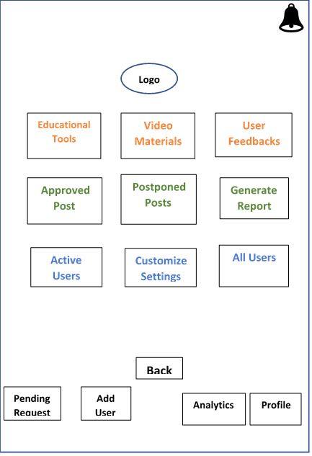

***Figure-3:*** *Wireframe of Admin dashboard*

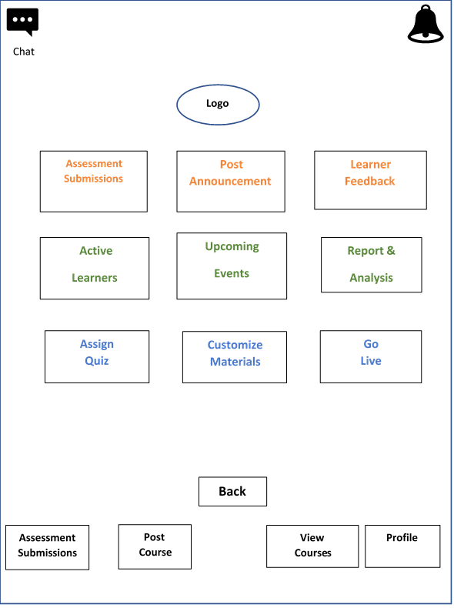

***Figure-4:*** *Wireframe of Course Instructor dashboard*

### Paper prototypes

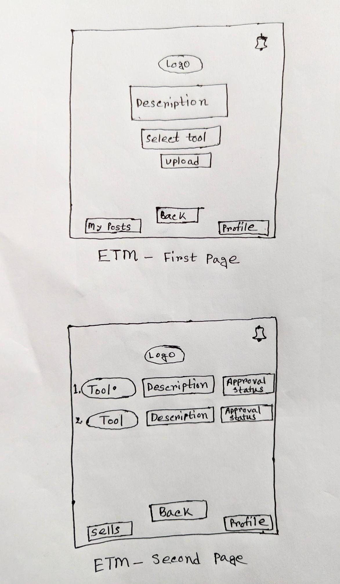

***Figure-5:*** *Paper prototype of Educational Tool Manufacturer dashboard (First Page)*



***Figure-6:*** *Paper prototype of Educational Tool Manufacturer dashboard (Second page)*

### Mockups

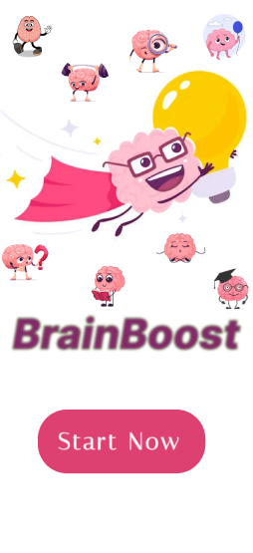 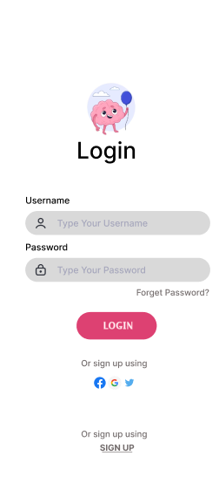

***Figure-7:*** *UI of Start page* ***Figure-8:*** *UI of Login page*

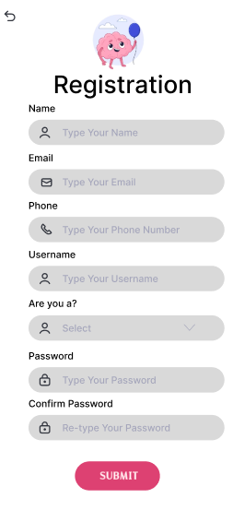 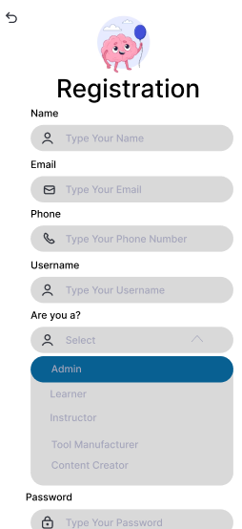

***Figure-9:*** *UI of Registration page-1* ***Figure-10:*** *UI of Registration page-2*

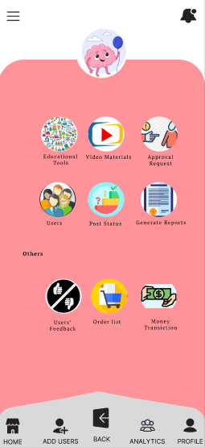 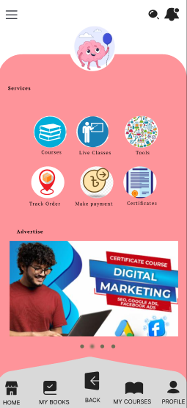

***Figure-11:*** *UI of Admin dashboard* ***Figure-12:*** *UI of Learner dashboard*

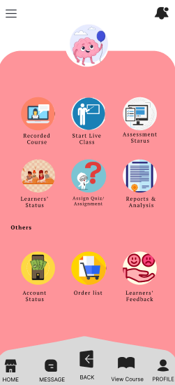 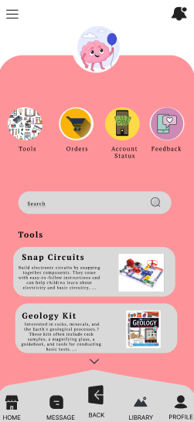

***Figure-13:*** *UI of Course Instructor dashboard* ***Figure-14:*** *UI of Educational Tool manufacture dashboard*

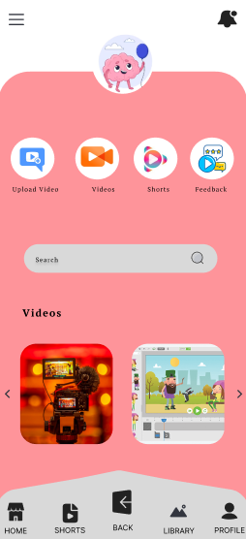

***Figure-15:*** *UI of Content Creator dashboard*

# COST Analysis:

▶ Effort = PM = Coefficient*(SLOC/1000) ^P

= 2.4(15000/1000) ^ 1.05

= 41

▶ Development time = DM = 2.50*(PM)^T

= 2.50*(41) ^ .38

= 10 Month

▶ Required number of people = ST = PM/DM

= 41/10

= 4

▶Designing & Coding = 10*22*8 [10 months,22 days, 8h]

= 1760 h

▶Total salary (developing and testing team) = 1760*1100 [1h salary =1100 Taka]

= 1936000 Taka [For 2 developer and 2 tester salary]

(1 developer and 1 tester salary =484000 Taka)

▶Per month salary = (484000/10) Taka

=48400 Taka (For 1 developer)

▶Requirement Analysis = 15*8*600 [15 days, 600 per hour salary]

= 72000 Taka

▶Maintenance = 2*4*6*2500 [per week 2h, 6 months]

= 120000 Taka

▶Testing tool online subscription = 10*5000 Taka

= 50000 Taka

▶Testing Cost = 20000*10 = 200000 Taka [Per month 20000 Taka]

▶Utilities Expenses = 3500*10= 35000 Taka

▶Training/Hardware = 3000*10 Taka

= 30000 Taka

▶Total Cost = (1936000+72000+120000+50000+200000+35000+3000) Taka

= 2416000 Taka

▶Profit margin = 2416000*15% = 362400 Taka

▶**Pay bill (client)** = (2416000+ 362400) = 2778400 Taka